The Tsantsas (Shrunken Heads)

Context
The tsantsas were created by the indigenous Jivaro tribes of South America, specifically during ritual practices following battles. These practices involved careful techniques in head-shrinking, which were deeply rooted in the Jivaro's spiritual beliefs (Rubenstein, 2007). Tsantsas were made for ceremonial purposes, often intended for use in religious rituals and to honor the spirits of deceased enemies. The heads were trophies of war, symbolizing control over the enemy and their spirit (Sauvageau et al., 2009).

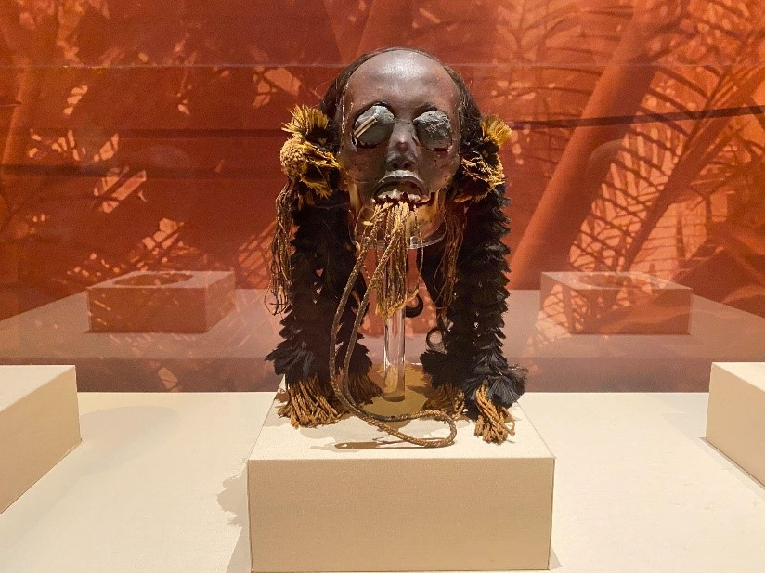
https://ctsciencecenter.org/wp-content/uploads/2022/08/Picture4-800x599.jpg

Significance
The size of a shrunken head is significant, as it symbolizes power over one’s enemy. Smaller heads, shrunk from a larger human head, are often seen as a display of victory and control. The transformation into a smaller size was not just a physical process but one tied to a belief in controlling the soul of the enemies (Rubenstein, 2007; Sauvageau et al., 2009). Tsantsas were made from human remains, specifically the skin and hair of the defeated. This use of materials highlights the deep spiritual connection that the Jivaro believed they had with their enemies. The shrinking process was meant to trap their soul, offering protection and power to the creator (Sauvageau et al., 2009; Vinovskis et al., 2018).

Technique
Creating a tsantsa requires special knowledge in traditional crafting techniques, including making incisions, removing and treating the skin, and shrinking it without losing facial features. These techniques were often passed down through generations and held significant cultural value (Sauvageau et al., 2009). The object engages multiple senses, sight shows us visual characteristics of the head. Touch offers the texture of the skin and hair, and possibly even smell due to the preservation methods used. This may have involved smoke or herbs. These sensory experiences contribute to its power and spiritual meaning in rituals (Rubenstein, 2007; Sauvageau et al., 2009).

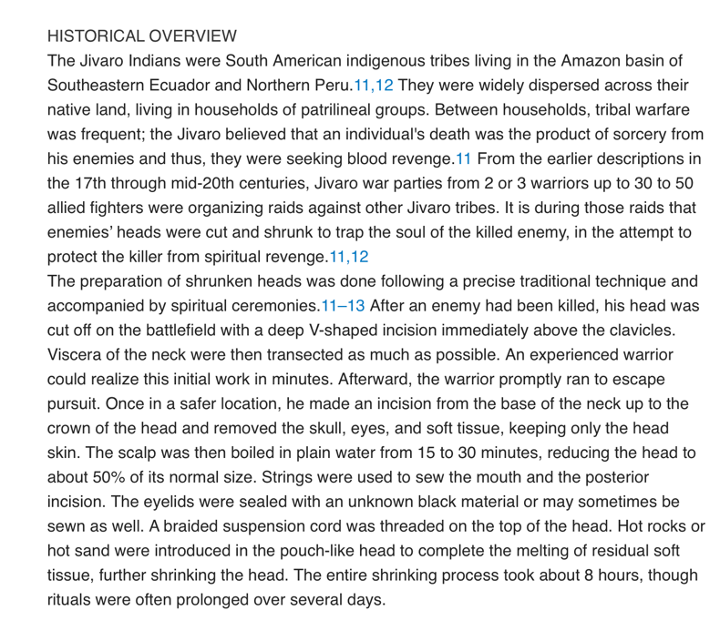
(Vinovskis et al., 2018).

Ritual context
The euphoric experience of a tsantsa can be complex. It might evoke feelings of reverence or horror depending on one’s cultural background. While to the Jivaro, it is a sacred object imbedded with spiritual power, to others it may appear grotesque or unsettling (Rubenstein, 2007). These shrunken heads play a key role in rituals that celebrate victories and protect the tribe. They serve as powerful symbols of revenge and justice, reinforcing cultural beliefs and practices through this display in rituals (Rubenstein, 2007; Sauvageau et al., 2009). The ritual context involves the head shrinking process, which is believed to capture the spirit of the enemy and confer power and safety to the tribe. This practice is deeply connected to warfare, spirituality, and cultural identity (Rubenstein, 2007). The creation and possession of tsantsas symbolize victory and dominance over enemies and reflect the social and spiritual hierarchies within the tribe. It showcases power dynamics where conquering and controlling an enemy’s spirit equates to authority and protection for the tribe (Rubenstein, 2007; Vinovskis et al., 2018).

